Loreen Henry

EPPS 6356: Data Visualization (Fall 2021)

Assignment 1

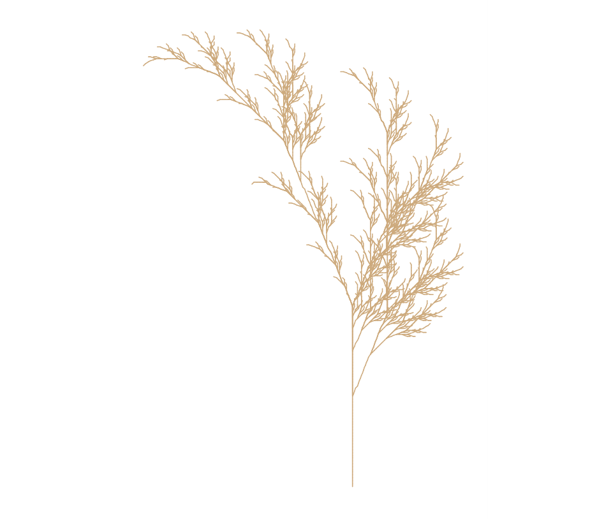

Image: Spring, Basic With No Color Enhancement